[Edge computing and 5G](https://www.techtarget.com/searchnetworking/feature/Edge-computing-and-5G-bring-the-edge-to-remote-workers)

Edge computing is a distributed information technology (IT) architecture in which client data is processed at the periphery of the network, as close to the originating source as possible.

Data is the lifeblood of modern business, providing valuable business insight and supporting real-time control over critical business processes and operations. Today's businesses are awash in an ocean of data, and huge amounts of data can be routinely collected from sensors and IoT devices operating in real time from remote locations and inhospitable operating environments almost anywhere in the world.

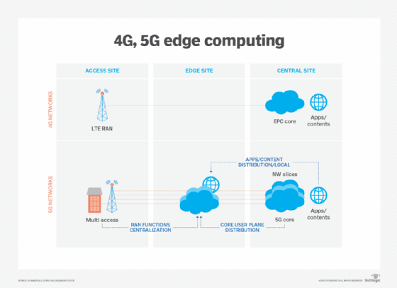

[**How does edge computing work**](https://www.techtarget.com/searchdatacenter/definition/edge-computing)

Edge computing is all a matter of location. In traditional enterprise computing, data is produced at a client endpoint, such as a user's computer. That data is moved across a WAN such as the internet, through the corporate LAN, where the data is stored and worked upon by an enterprise application. Results of that work are then conveyed back to the client endpoint. This remains a proven and time-tested approach to client-server computing for most typical business applications. 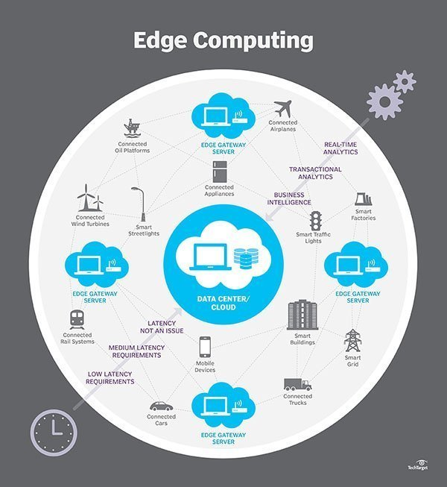

### Edge vs. cloud vs. fog computing

Edge computing is closely associated with the concepts of cloud computing and [fog computing](https://internetofthingsagenda.techtarget.com/definition/fog-computing-fogging). Although there is some overlap between these concepts, they aren't the same thing, and generally shouldn't be used interchangeably. It's helpful to compare the concepts and understand their differences.

One of the easiest ways to understand the [differences between edge, cloud](https://internetofthingsagenda.techtarget.com/tip/Comparing-edge-computing-vs-cloud-computing) and fog computing is to highlight their common theme: All three concepts relate to [distributed computing](https://www.techtarget.com/whatis/definition/distributed-computing) and focus on the physical deployment of compute and storage resources in relation to the data that is being produced. The difference is a matter of where those resources are located.

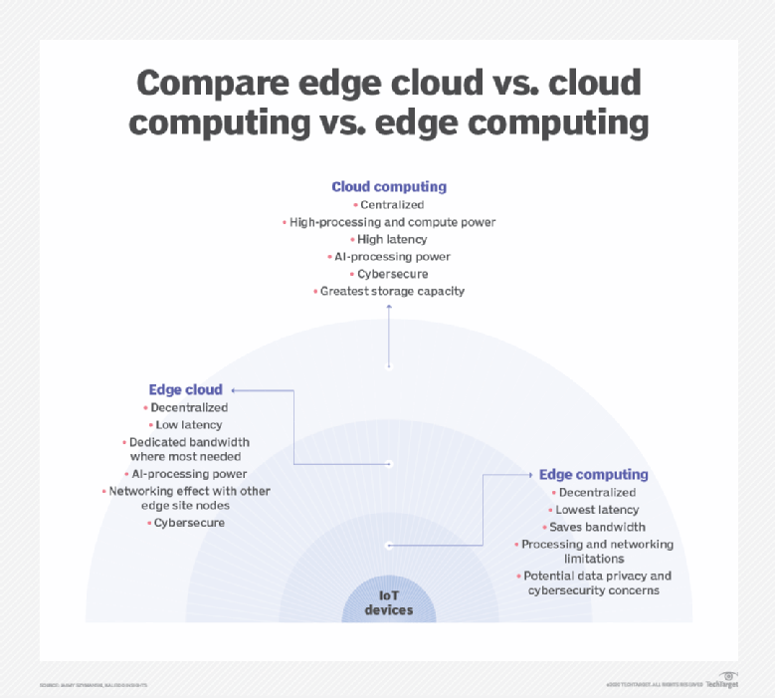

1. Edge. Edge computing is the deployment of computing and storage resources at the location where data is produced. This ideally puts compute and storage at the same point as the data source at the network edge. For example, a small enclosure with several servers and some storage might be installed atop a wind turbine to collect and process data produced by sensors within the turbine itself. As another example, a railway station might place a modest amount of compute and storage within the station to collect and process myriad track and rail traffic sensor data. The results of any such processing can then be sent back to another data centre for human review, archiving and to be merged with other data results for broader analytics.
2. Cloud. Cloud computing is a huge, highly scalable deployment of compute and storage resources at one of several distributed global locations (regions). Cloud providers also incorporate an assortment of pre-packaged services for IoT operations, making the cloud a preferred centralized platform for IoT deployments. But even though cloud computing offers far more than enough resources and services to tackle complex analytics, the closest regional cloud facility can still be hundreds of miles from the point where data is collected, and connections rely on the same temperamental internet connectivity that supports traditional data centres. In practice, cloud computing is an alternative -- or sometimes a complement -- to traditional data centres. The cloud can get centralized computing much closer to a data source, but not at the network edge.
3. Fog. But the choice of compute and storage deployment isn't limited to the cloud or the edge. A cloud data centre might be too far away, but the edge deployment might simply be too resource-limited, or physically scattered or distributed, to make strict edge computing practical. In this case, the notion of fog computing can help. Fog computing typically takes a step back and puts compute and storage resources "within" the data, but not necessarily "at" the data.

